Boulder Mountain Copper Gold Silver Property

Summary:
The Boulder Mountain Property is located in the Similkameen region of South Western British Columbia. The Boulder Mountain Property consists of four contiguous claims comprising 703.64 ha. The Boulder Mountain is underlain by andesitic to locally dacitic flows and pyroclastic of the upper Triassic Nicola group. These rocks are uncomformably overlain by felsic to intermediate volcanics of the middle to upper cretaceous Spence’s bridge group. These volcanic rocks are highly prospective for epithermal style gold mineralization.

Location:
The Boulder Mountain mineral claims are located 7.5 km north-northwest of Tulameen, B.C., in the Similkameen mining division. It is significant that the claim block lies within the mountain pine beetle area and has recently been logged. This has greatly improved access to all areas of the property, which previously had poor access.

Mineralization:

Key zones include:
- South Copper: A 1–3 m thick, sulphide-rich horizon with chalcopyrite-pyrite stringers and quartz-carbonate veins, mapped over ~150 m and delivering drill intercepts of 1.29 % Cu over 2.1 m, and surface grab values up to ~20 % Cu and ~88 g/t Ag (MINFILE 092HNE122).
- Mid Copper: Similar sulphide horizon within andesite, capped locally by silicified felsic tuff; assays include ~0.31 % Cu over 1.5 m (MINFILE 092HNE123).
- James X: Polymetallic vein showing with pyrite-chalcopyrite massive sulfide bands (30 % chalcopyrite) yielding 1.25 % Cu, 7.5 g/t Ag, and notable Zn–Pb values (MINFILE 092HNE016).
- North Copper: Subvolcanic, vein-hosted mineralization in chlorite schist and andesite, featuring chalcopyrite-bearing quartz veins and grab samples with ~2.94 % Cu, ~38.7 g/t Ag, and ~0.8 % Zn (MINFILE 092HNE007).

History:

This copper deposit was first explored in 1901. The prospect remained largely undeveloped until Gold River Mines Ltd. conducted trenching and drilled 9 holes totalling 894 metres during 1972 and 1973. Since then, the deposit has been trenched, mapped and sampled by various operators between 1980 and 2025.

Potential:
The Boulder Mountain Property presents strong exploration potential due to the presence of multiple mineralization styles within a relatively compact area. The stratiform VMS horizons demonstrate continuity and grade potential, while the polymetallic veins and subvolcanic Cu–Ag–Au systems highlight opportunities for localized high-grade zones. Historical work has shown consistent copper values with accessory silver, zinc, and lead, indicating the potential for a broader polymetallic resource. The combination of favourable host rocks, widespread hydrothermal alteration, and evidence of multiple mineralizing events suggest that further mapping, geophysics, and targeted drilling could expand known mineralized zones and potentially discover new ones at depth or along strike.

Recommendations:
It is recommended that a staged exploration program be completed on the Boulder Mountain Property, beginning with geological mapping to refine stratigraphy, structures, and alteration. Rock and soil sampling should be carried out to better define known mineralized zones and identify new geochemical targets. A property-wide airborne geophysical survey is recommended to provide a regional framework and assist in identifying additional sulphide-rich horizons and structural controls on mineralization.

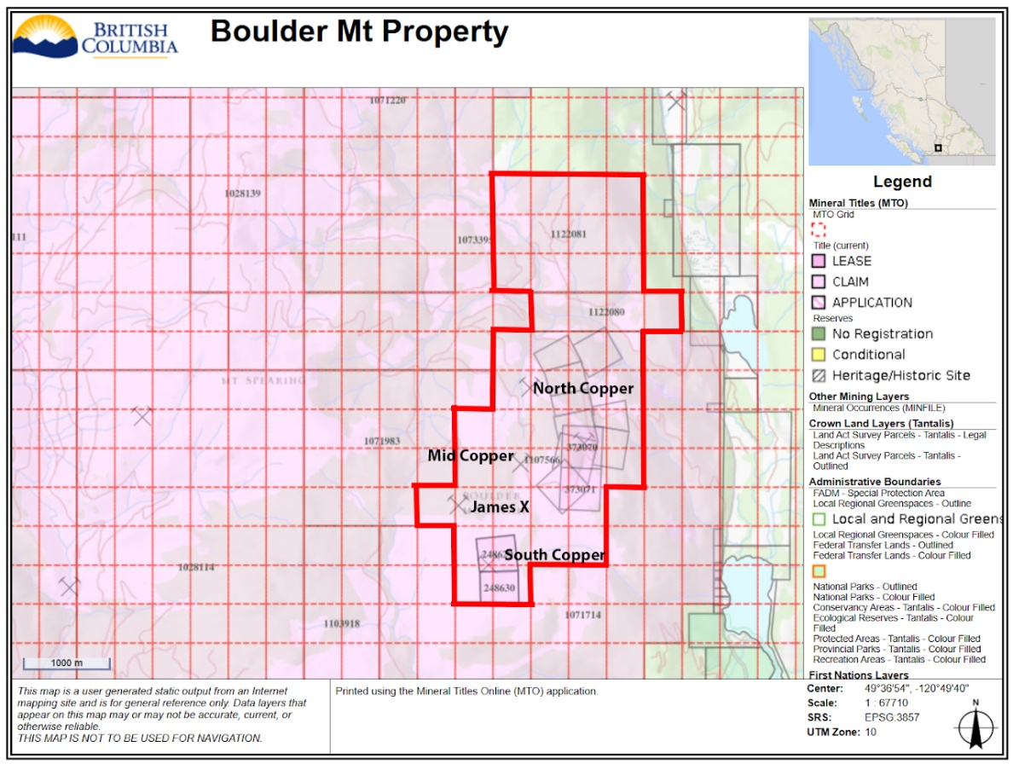

Owner:
Platinum Belt Resources (100% Owner)
(mikeadam@platinumbeltresources.com)

